Instructions for using Web notes

Contents

New Consignment 1

Enter Customer details 1

Enter Parcel size 2

Dangerous goods (Optional) 2

Courier service (Optional) 2

Saturday delivery (Optional) 3

Delivery instructions (Optional) 3

Print Labels 3

Next Consignment 3

1. Login.

## New Consignment

1. Click Consignments

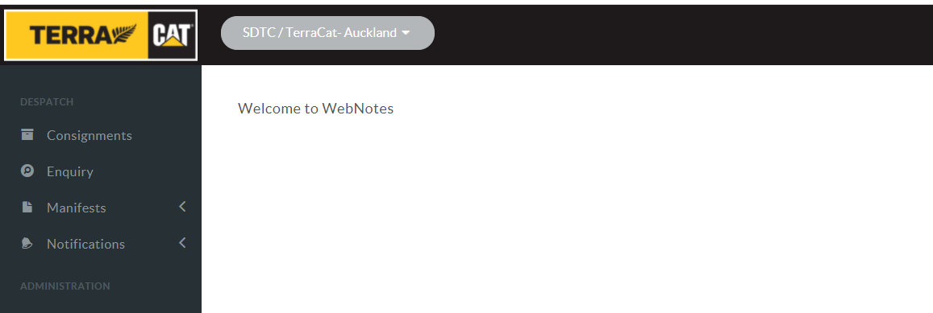

1. Click new consignment

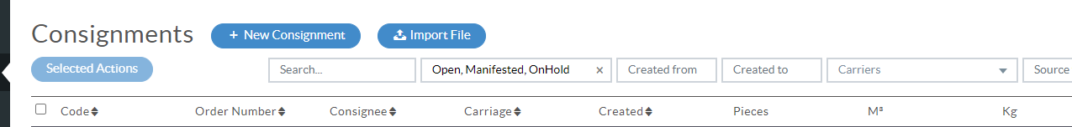

## Enter Customer details

1. Enter customer name and see if address is right
2. Click under consignment ref and write customer refence Example console or Attn: bob
3. Click under Order Number and type order number EG. Sps123466789 or TO123456.

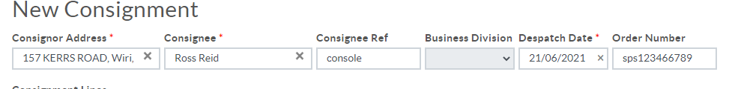

## Enter Parcel size

1. Open the drop-down box under package type and select package type (size)

(If you have a non-standard size box select CTN: Carton or PLT pallet

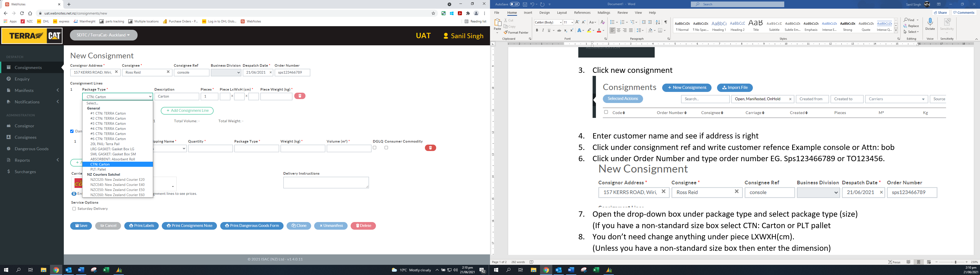

1. You don’t need change anything under piece LXWXH(cm).

(Unless you have a non-standard size box then enter the dimension)

1. Under piece Weight, enter the weight.
2. If there are more pieces, click add consignment lines and repeat process. Otherwise proceed to the next step.



## Dangerous goods (Optional)

1. If you have any dangerous goods, tick dangerous good, other wise proceed to the next step.
2. Under class, select the class.
3. Under proper shipping name, select the name
4. Quantity, enter the quantity.
5. Under package type, enter package type, example carton or pallet.
6. Under weight, enter the weight
7. Under volume, enter the volume example 0.01m3.



1. If there are more pieces, click add dangerous goods and repeat process. Otherwise proceed to the next step.



## Courier service (Optional)

1. Select which courier service you want.

(Default is setup to NZC)

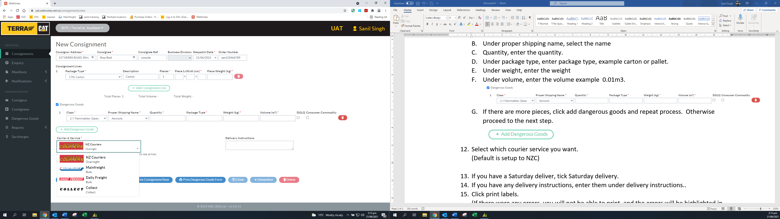

## Saturday delivery (Optional)

1. If you have a Saturday deliver, tick Saturday delivery.

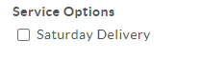

## Delivery instructions (Optional)

1. If you have any delivery instructions, enter them under delivery instructions..

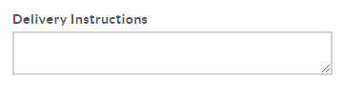

## Print Labels

1. Click print labels.

(If there were any errors, you will not be able to print, and the errors will be highlighted in red)

1. If you had any dangerous goods, click print dangerous goods forms.
2. If consignment note is required, click on print consignment note.



All required stickers and forms should have printed out.

# Next Consignment

1. Click Save and continue to the next consignment